

**7BUIS030W Data System Concepts and Fundamentals**

**Tutorial-01 ,2021**

**To answer the questions in this tutorial , please refer to Lecture-2 in Blackboard/Learning Resources/ Week 2/ Studymaterials**

**Tutorial 01 Exercise 01**

A hotel chain has multiple hotels managed by respective hotel managers. Identify two entities that can be included in the database and at least 4 attributes for each entity.

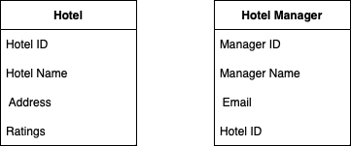

**Tutorial 01 Exercise 02**

Alex is creating a database to store the details of all his books and its author information. He entered the data in the table as follows.

|  |  |  |  |  |  |  |
| --- | --- | --- | --- | --- | --- | --- |
| Book_ID | Title | Publisher | Date_  Published | Author Name | Author DOB | Author Nationality |
| 1 | Harry Potter and the Sorcerer’s stone | Bloomsbury | 1997 | J K Rowling | 31/07/1965 | British |
| 2 | Harry Potter and Chamber of Secrets | Bloomsbury | 1998 | J K Rowling | 31/07/1965 | British |
| 3 | Harry Potter and the Prisoner of Azkaban | Bloomsbury | 1999 | J K Rowling | 31-07-1965 | British |

* 1. Identify the following:

*Field: Columns used to capture attributes.*

*Record: each row representing each entry.*

*File: Table containing the fields and records.*

* 1. Explain what is meant by :

*Data Redundancy: Repeated entry of the same data leading to more memory usage.*

*Data Inconsistency: The occurrence of error due to repeated entry of the same data.*

* 1. Explain how the above database design can be restructured to avoid the problems listed in Question 2.2

By creating a creating a relational database to avoid data redundancy and inconsistency.

**Tutorial 01 Exercise 03**

For each of the following descriptions, create a simple conceptual ERD for each of the following descriptions. Make sure you include the entity names and relationship names

* 1. A student enrols for a course in the University.



* 1. The courses in the University are delivered by lecturers.



* 1. Every lecturer in the university owns a computer in his/her office



* 1. Represent all the conceptual ERDs described in 3.1., 3.2., 3.3 as a single conceptual ERD.

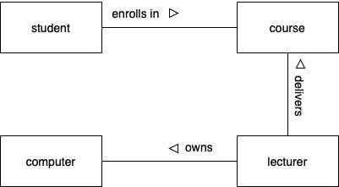

**Tutorial 01 Exercise 04**

Create a basic conceptual ERD for the following scenario. Include entities, attributes and relationships names.

A local library database is been set up. Every librarian is in charge of the books that are borrowed by the user. Every librarian is also allocated a number of publishers with whom they get in contact frequently to find out about the latest publications.

